Homework EECE 200
Samer Hodroj 201100607
Problem 1:
a-
Amplitude Y1: 1V
Amplitude Y2:0.49V
Amplitude Y3:0.33V
b- Signal Y1: Frequency: 1/period=475.5 Hz
Period:0.0021 sec
Angular frequency: 2Πf= 2987.65rad/sec
Signal Y2: Frequency: 1/period=793 Hz
Period:0.0012 sec
Angular frequency: 2Πf= 4982.56 rad/sec
Signal Y3: Frequency:1/period=158.8 Hz
Period:0.0063 sec
Angular frequency: 2Πf= 997.76 rad/sec
c- Y2 has the biggest frequency.
d-
To find Ѳ, we could replace t by 0 in the equation of the form of y(t)=A sin(wt+θ),and find Ѳ:
For Y1: Since the curve representing Y1 is passing through (0,0) and it’s increasing, then Ѳ=0
from the graph, y1(0)=A sin(wt + Ѳ1)=0
A and w are constant .Then sin(Ѳ1)=0 then Ѳ1=0 or π. If we derive y(t) with respect to t, we will have: y(t)’=wAcos(wt+ Ѳ). Y1 is increasing then its slope will be positive. Y1(t)’ is positive. For t=0, w is positive and A is positive too. In consequently, cos (wt+ Ѳ) is positive too. At t=o, cos(Ѳ) is positive. Ѳ can’t be equal to π because cos(π)=-1.
Ѳ1=0
For Y2: The curve representing Y2 is shifted of a quarter of period to the curve of Y1.Ѳ is equal to 1/4of a period.One period is for 2π.Then, its phase would be π/2.
from the graph, y2(0)=A sin(wt + Ѳ2)=0.5=A
Then sin(Ѳ1)=1 then Ѳ1=π/2 or –π/2. If we derive y(t) with respect to t, we will have: y(t)’=wAcos(wt+ Ѳ). Y1 is decreasing then its slope will be negative. Y(t)’ is negative. For t=0, w is positive and A is positive too. . In consequently, cos (wt+ Ѳ) is negative. At t=o, cos(Ѳ) is equal to 0.If we derive again, since the curve is concave at t=0, then this second derivative should be negative.y2(t)’’=-w²Asin(Ѳ+wt).At t=0, y2(0)’’=-w²Asin(Ѳ). –w² is negative, A is positive, then sin(Ѳ) should be positive since y2(t)’’ is negative.sin(π/2) is positive.
Ѳ2=π/2

For Y3: The curve representing Y3 is passing through (0,0). It’s decreasing. Then , Ѳ=π
from the graph ,y3(0)=A sin(wt + Ѳ3)=0
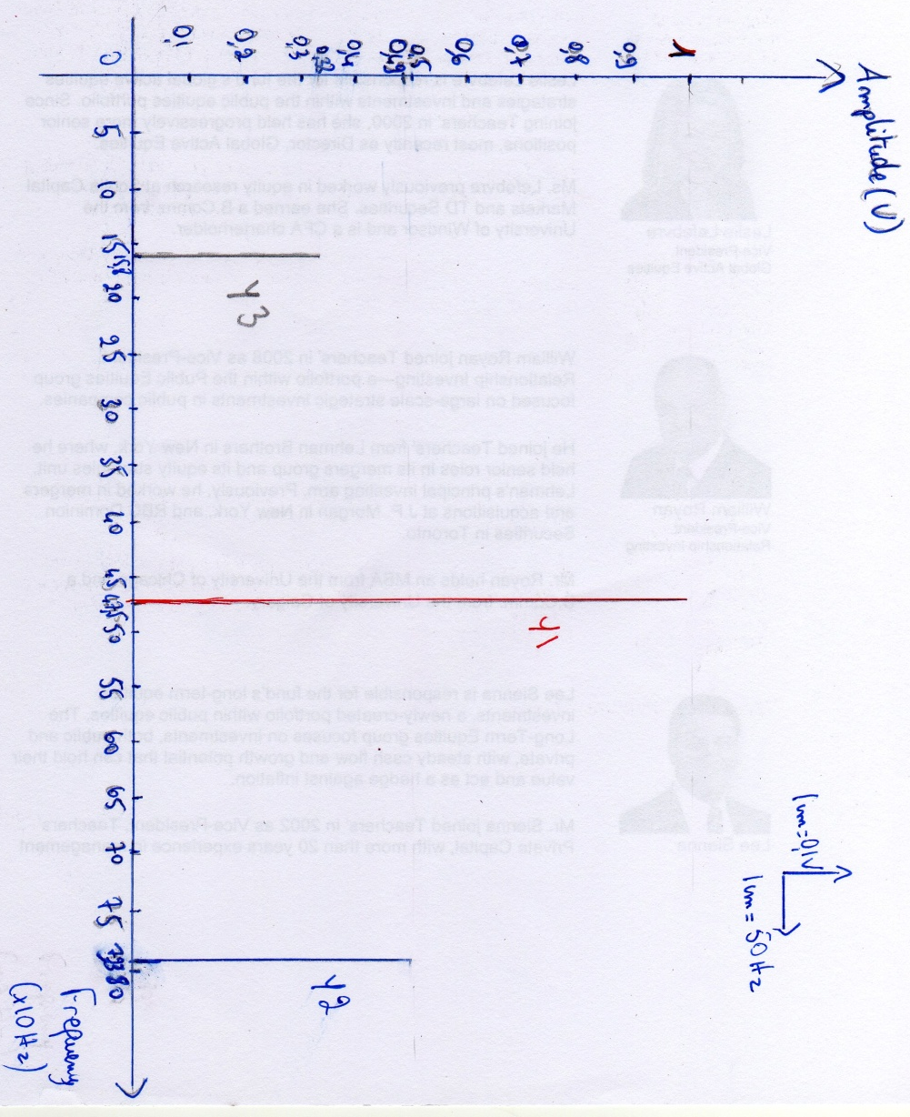
A and w are constant .Then sin(Ѳ3)=0 then Ѳ3=0 or π. If we derive y(t) with respect to t, we will have: y(t)’=wAcos(wt+ Ѳ). Y1 is decreasing then its slope will be negative. Y3(t)’ is negative. For t=0, w is positive and A is positive too. In consequently, cos (wt+ Ѳ) is negative. At t=o, cos (Ѳ) is negative. Ѳ can’t be equal to 0 because cos (π) =1. Ѳ3=π

Y2
Y1
Y3
Problem 2:
- Radio “Tomorrow Voice”:1620 KHz. The AM dedicated bandwidth is between 530 to 1700 KHz.
- The FM dedicated bandwidth is between 88 and 108 MHz Every station is assigned 200 KHz. Thus, the bandwidth can afford 100 stations.
- Yes, the bandwidth of TV stations is bigger than FM stations because images and sounds are being transmitted from TVs while only sounds are transmitted from radios. The bandwidth of every station for a simple black and white TV is almost 5.5125 MHz There are more than 4 TV stations. The total bandwidth dedicated to FM adios is 20MHz. Moreover, TVs transmit sounds and image so they need a bigger bandwidth. Thus, the bandwidth of TV stations is bigger than FM stations.
Problem 3:
- The dimensions of the picture are 4*4=16.
- Since there is 4 levels of grey so every pixel is represented by 2 bits ( n²=4 then n=2)
White: 11
Light Gray: 10
Dark Gray: 01
Black: 00
- White: 3
Light Gray: 2
Dark Gray: 1
Black: 0
So the matrix of this picture is: [ 0 2 3 0
3 0 2 3
1 3 3 3
1 3 3 1]
- Number of bits in a frame: 32 bits.
Number of bits in 25 frames/sec: 32*25=800 bits/sec.
5min= 300s
Number of bits n a movie of 5 min: 800*300=240000bits
1bit=0.125byte
240000bits=30000bytes
1 megabytes = 1 048 576 bytes
30000bytes=28*10⁻³Megabytes

The size of the file would be 28*10⁻³Megabytes.

Problem 4:

- 10110101.01012= 1* 2⁻⁴ + 0*2⁻³ + 1*2⁻² + 0*2⁻¹ + 1*2⁰ + 0*2 + 1*2² +0*2³ +1*2⁴ + 1*2⁵ +0*2⁶ +1 *2⁷=181.3125
- 548.2310= 548₁₀ +0.23₁₀
548/2=274 r=0
274/2=137 r=0
137/2=68 r=1
68/2=34 r=0
34/2=17 r=0
17/2=8 r=1
8/2=4 r=0
4/2=2 r=0
2/2=1 r=0
½=0 r=1
548₁₀=1000100100₂
0.23 *2=0.46 0
0.46*2=0.92 0
0.92*2=1.84 1
0.84*2=1.68 1
0.68*2=1.36 1
0.36*2=0.72 0
0.72*2=1.44 1
0.44*2=0.88 0
0.88*2=1.76 1
1 period
0.76*2=1.52 1
0.52*2=1.04 1
0.04*2=0.08 0
0.08*2=0.16 0
0.16*2=0.32 0
0.32*2=0.64 0
0.64*2=1.28 1
0.28*2=0.56 0
0.56*2=1.12 1
0.12*2=0.24 0
0.24*2=0.48 0
0.48*2=0.96 0
0.96*2=1.92 1
0.92*2=1.84 1
0.84*2=1.68 1
We can notice that 0.23 in binary is an infinite periodic number after a certain range of number. The period starts after the second bit .The length of the period is 20 bits.
0.23₁₀=0.001110101110000101000111…₂
Then 548.23₁₀=1000100100.001110101110000101000111…₂
c- We have 15468.To get its binary representation; we transform each digit of 1546 into set of 3 bits and then add them.
6: 6/2=3 r=0
3/2=1 r=1
½=0 r=1
Then, 6₈=110₂
4: 4/2=2 r=0
2/2=1 r=0
½=0 r=1
Then, 4₈=100₂
5: 5/2=2 r=1
2/2=1 r=0
½=0 r=1
Then, 5₈=101₂
1:1/2=0 r=1
Then, 1₈=001₂ or simply 1₂
So, 1546₈=1101100110₂
d-1000111002: To give the hexadecimal representation of this number, we should split it into groups of 4 digits and transform each one in a hexadecimal representation and then add them.
1100₂: 0*2⁰+0*2¹+2*2²+2*2³=C₁₆
0001₂:1*2⁰+0*2¹+0*2²+0*2³=1₁₆
0001₂:1₁₆
Then, 1000111002 is in hexadecimal 11C₁₆
e-118B16: To get its binary representation, we transform each digit of 1546 into set of 4 bits and then add them.
B₁₆ is equivalent to 11_{10.} 11 are in binary: 11/2=5 r=1
5/2=2 r=1
2/2=1 r=0
½=0 r=1
B_{16 or} 11₁₀ are equivalent to 1011₂
8₁₆: 8/2=4 r=0
4/2=2 r=0
2/2=1 r=0
½=0 r=1
8₁₆ is in binary 1000₂
1₁₆: ½=0 r=1
1₁₆ are in binary 0001₂ or simply 1₂.
Then, 118B₁₆ is in binary 1000110001011₂

